DS.140 Integration Design Specification



Update Supplier Site Integration

SCM_RICE_323

Author: Pranjul Garg

Creation Date: May 21, 2022

Last Updated: May 21, 2022

Version: 1.0

**Approvals:**

|  |  |
| --- | --- |
| <Approver 1> | <Rakesh Khanna / Naushad / Amit> |
| <Approver 2> | <Business Owner> |

# Document Control

## Change Record

| Date | Author | Version | Change Reference |
| --- | --- | --- | --- |
| 21-May-2022 | Pranjul Garg | 1.0 | No Previous Document |
|  |  |  |  |
|  |  |  |  |
|  |  |  |  |

2

## Reviewers

| Name | Position |
| --- | --- |
| FHL Business | Business User |
| FHL IT Group | Fortis IT Team |
|  |  |
|  |  |

Contents

1 Document Control ii

1.1 Change Record ii

1.2 Reviewers ii

2 Introduction 4

2.1.1 Scope for this Document 4

2.1.2 Intended Audience 4

3 Overview 5

3.1 Business Objectives 5

3.2 Major Features 5

3.3 Glossary 5

4 High-Level Fusion Integration flow 6

5 Technical Design Details 7

5.1 OIC Services 7

5.2 Oracle PaaS DBCS components 8

5.3 Technical flow 8

6 Data FIELD Mapping 12

6.1 File format 12

6.2 Frequency 12

7 Exception handling 13

7.1 Scenarios 13

8 Assumptions / Considerations 14

9 Open and Closed Issues 15

9.1 Open Issues 15

9.2 Closed Issues 15

# Introduction

### Scope for this Document

This analysis specification document is prepared to layout the design for an integration to update the supplier site status based on the drug license information at the Supplier DFF level.

### Intended Audience

This document is intended for the following groups to provide the action items and consideration that are required to complete the implementation of the various Supply Chain and Finance related functionalities from Oracle Fusion.

#### Fortis Business Users

This document will be helpful for Fortis Business users to understand the technical design and process change with the new structure implemented in Oracle. The business user will validate this document after the verification of the requirement.

#### PwC Technical Team

The PwC technical team will use this document as a source technical design document to develop the technical solution to implement / deploy in Oracle Fusion.

#### Fortis IT Team

The Fortis IT Team must facilitate the PwC technical team for requisite details and other elements required from Business. The Fortis IT team is also responsible to arrange and provide required technical information wherever is required.

# Overview

Fortis Healthcare Limited (FHL) is a chain of hospitals, headquartered in India. Fortis started its health care operations from Mohali where first Fortis hospital was started. Later, the hospital chain purchased the healthcare branch of the Escorts group and increased its strength in various parts of the country. The Fortis health care also operates its hospital in Vasant Kunj, Faridabad, Gurgaon. The FMRI hospital at Gurgaon is the headquarter of Fortis healthcare with all the major facilities at the hospital.

This specification document is prepared to layout the design for an integration to update the supplier site status based on the drug license information at the Supplier DFF level.

## Business Objectives

The following are the business objectives.

1. To have a secure, reliable, and scalable design flow to fetch the supplier site where the supplier site status has to be updated.
2. To have a solution providing the monitoring capabilities.

## Major Features

The proposed solution will have the following features involved:

1. OIC integration invokes Fusion BI report to fetch the eligible supplier site data along with the relevant status.
2. The OIC integration then invokes a REST API to update the supplier site accordingly.

## Glossary

REST

Representational State Transfer.

OIC

Oracle Integration Cloud

# High-Level Fusion Integration flow

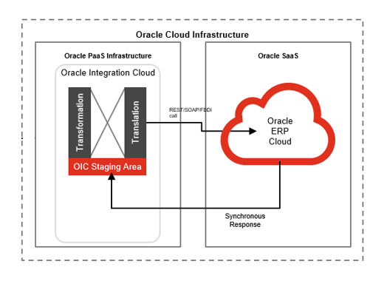

# Technical Design Details

This section describes the technical details of all the components involved in the design for an integration to update the supplier site status based on the drug license information at the Supplier DFF level.

## OIC Services

An App driven orchestration has been designed in OIC to build a REST Endpoint URL:

|  |  |
| --- | --- |
| **OIC Integration Name** | Fortis Supplier Site Status Update Integration |
| **OIC REST Endpoint URL** | <https://oic-prod-nr5lr39yailj-bo.integration.ocp.oraclecloud.com:443/ic/api/integration/v1/flows/rest/FORTIS_SUPP_SITE_UPDATE_INTG/1.0/supplierSiteUpdate/> |
| **Method** | POST |

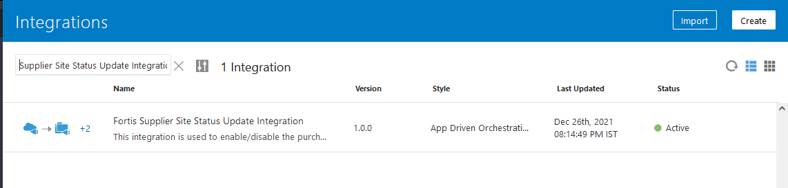

This is an app driven integration which is invoked via a following common scheduled OIC integration:

|  |  |
| --- | --- |
| **OIC Integration Name** | Fortis Trigger 30m Integration |
| **OIC REST Endpoint URL** | [NA](https://oic-prod-nr5lr39yailj-bo.integration.ocp.oraclecloud.com:443/ic/api/integration/v1/flows/rest/FORTIS_TRIG_GRN_PUT_AWAY_TXN_INT/1.0/grnPutAway/) |
| **Method** | NA |
| **Frequency** | Scheduled every 30 minutes |

This wrapper scheduled integration has been configured due to the limit of scheduled integrations within OIC. Hence all the required scheduled integrations have been clubbed together as per their required frequency.

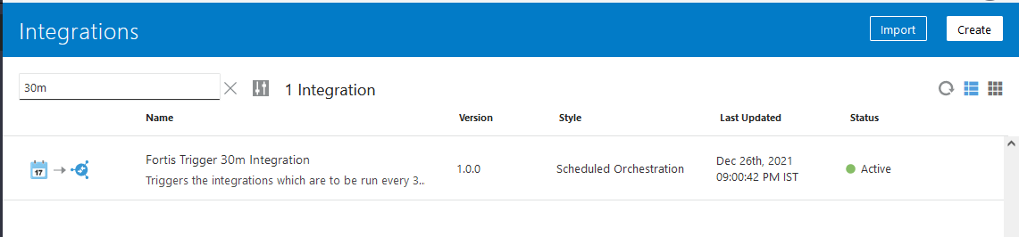

## Oracle PaaS DBCS components

This integration design does not use any DBCS related component.

## Technical flow

Following is the complete technical flow for this integration design:

1. A common scheduled OIC integration (Fortis Trigger 30m Integration) invokes this integration to update the supplier site status as per the drug license information.
2. The OIC integration invokes ESS Job: Fortis Supplier Site Update Report (path: /oracle/apps/ess/custom/payables/supplier/) which internally invokes BI Report: Fortis Supplier Site Update Report to fetch the eligible supplier site records.
3. This BI report uses the following query to fetch the eligible supplier site records. HPS.ATTRIBUTE_DATE1 is the Drug license expiry date. The basic aim is to be enabled the deactivated supplier site if its drug license is active. If drug license has expired and the supplier site is still active, then the supplier site has to be deactivated.

SELECT ps.vendor_id,

ps.vendor_name,

pss.vendor_site_id*-- ,pss.vendor_site_code*

,

'INACTIVE' Status,

SYSDATE Inactivate_Date,

'false' purchase_flag,

'Drug License' Supplier_Type,

'Supplier Status Update' action

FROM POZ_SUPPLIERS_V ps, poz_supplier_sites_all_m pss, hz_party_sites hps

WHERE 1 = 1

AND ps.party_id = hps.party_id

AND pss.party_site_id = hps.party_site_id

AND hps.status = 'A'

AND hps.ATTRIBUTE1 IS NOT NULL

AND hps.ATTRIBUTE_DATE1 < SYSDATE

AND NVL (ps.END_DATE_ACTIVE, SYSDATE + 1) >= SYSDATE

*--AND ps.VENDOR_TYPE_LOOKUP_CODE = 'PHARMA'*

AND ps.vendor_id = pss.vendor_id

AND NVL (pss.PURCHASING_SITE_FLAG, 'N') = 'Y'

AND NOT EXISTS

(SELECT 1

FROM PO_HEADERS_ALL

WHERE VENDOR_ID = ps.vendor_id

UNION

SELECT 1

FROM POR_REQUISITION_LINES_ALL

WHERE VENDOR_ID = ps.vendor_id)

UNION

SELECT ps.vendor_id,

ps.vendor_name,

pss.vendor_site_id*-- ,pss.vendor_site_code*

,

'ACTIVE' Status,

NULL Inactivate_Date,

'true' purchase_flag,

'Drug License' Supplier_Type,

'Supplier Status Update' action

FROM POZ_SUPPLIERS_V ps, poz_supplier_sites_all_m pss, hz_party_sites hps

WHERE 1 = 1

AND ps.party_id = hps.party_id

AND pss.party_site_id = hps.party_site_id

AND hps.status = 'A'

AND hps.ATTRIBUTE1 IS NOT NULL

AND hps.ATTRIBUTE_DATE1 > SYSDATE

AND NVL (ps.END_DATE_ACTIVE, SYSDATE + 1) > SYSDATE

*--AND ps.VENDOR_TYPE_LOOKUP_CODE = 'PHARMA'*

AND ps.vendor_id = pss.vendor_id

AND NVL (pss.PURCHASING_SITE_FLAG, 'N') = 'N'

AND NOT EXISTS

(SELECT 1

FROM PO_HEADERS_ALL

WHERE VENDOR_ID = ps.vendor_id

UNION

SELECT 1

FROM POR_REQUISITION_LINES_ALL

WHERE VENDOR_ID = ps.vendor_id)

UNION

SELECT ps.vendor_id,

ps.vendor_name,

pss.vendor_site_id*-- ,pss.vendor_site_code*

,

'INACTIVE' Status,

SYSDATE Inactivate_Date,

'false' purchase_flag,

'Drug License' Supplier_Type,

'Supplier Status Update' action

FROM POZ_SUPPLIERS_V ps, poz_supplier_sites_all_m pss, hz_party_sites hps

WHERE 1 = 1

AND ps.party_id = hps.party_id

AND pss.party_site_id = hps.party_site_id

AND hps.status = 'A'

AND hps.ATTRIBUTE1 IS NOT NULL

AND hps.ATTRIBUTE_DATE1 < SYSDATE

AND NVL (ps.END_DATE_ACTIVE, SYSDATE + 1) >= SYSDATE

*--AND ps.VENDOR_TYPE_LOOKUP_CODE = 'PHARMA'*

AND ps.vendor_id = pss.vendor_id

AND NVL (pss.PURCHASING_SITE_FLAG, 'N') = 'Y'

AND EXISTS

(SELECT 1

FROM PO_HEADERS_ALL

WHERE VENDOR_ID = ps.vendor_id

UNION

SELECT 1

FROM POR_REQUISITION_LINES_ALL

WHERE VENDOR_ID = ps.vendor_id)

UNION

SELECT ps.vendor_id,

ps.vendor_name,

pss.vendor_site_id*--,pss.vendor_site_code*

,

'ACTIVE' Status,

NULL Inactivate_Date,

'true' purchase_flag,

'Drug License' Supplier_Type,

'Supplier Status Update' action

FROM POZ_SUPPLIERS_V ps, poz_supplier_sites_all_m pss, hz_party_sites hps

WHERE 1 = 1

AND ps.party_id = hps.party_id

AND pss.party_site_id = hps.party_site_id

AND hps.status = 'A'

AND hps.ATTRIBUTE1 IS NOT NULL

AND hps.ATTRIBUTE_DATE1 > SYSDATE

AND NVL (ps.END_DATE_ACTIVE, SYSDATE + 1) > SYSDATE

*--AND ps.VENDOR_TYPE_LOOKUP_CODE = 'PHARMA'*

AND ps.vendor_id = pss.vendor_id

AND NVL (pss.PURCHASING_SITE_FLAG, 'N') = 'N'

AND EXISTS

(SELECT 1

FROM PO_HEADERS_ALL

WHERE VENDOR_ID = ps.vendor_id

UNION

SELECT 1

FROM POR_REQUISITION_LINES_ALL

WHERE VENDOR_ID = ps.vendor_id)

1. The above query returns “STATUS” as per the respective scenario of a given supplier site and in OIC, the logic accordingly activate or deactivate the supplier site.
2. This OIC integration then invokes the following REST API for each & every record to update the supplier site:

|  |  |
| --- | --- |
| REST API URL | https://fa-ermg-saasfaprod1.fa.ocs.oraclecloud.com/fscmRestApi/resources/11.13.18.05/suppliers/{SupplierId}/child/sites/{SupplierSiteId} |
| Method | PATCH |
| Request Payload | {  "SitePurposePurchasingFlag" : false  } |
| Response Payload | NA |

**Server details:**

|  |  |  |  |  |
| --- | --- | --- | --- | --- |
| **Server** | **Host name** | **Port** | **Service Name** | **Username** |
| Oracle PaaS DB | 140.238.225.129 | 1521 | PRODPDB1.fhpubsn.fhvcn.oraclevcn.com | XXFH & XXFH_RO |



# Data FIELD Mapping

NA

## File format

NA

## Frequency

The integration is scheduled to run every 30 minutes.

# Exception handling

There can be various scenarios for an error to occur. This section defines those error scenarios, and the exception handling has been done to notify and act accordingly.

## Scenarios

In a tabular format give list of scenarios and exception handling

* If any of the step or node fails within the OIC integration, Global Fault section is configured within this OIC integration to send an OIC error notification with relevant details.
* The email id has been stored in OIC Lookup: Fortis_FaultNotification_EmailAddress_Lookup against the given OIC integration name.
* It also sends a notification whenever integration processes any data. This notification also acts as a confirmation that the integration has been running fine.

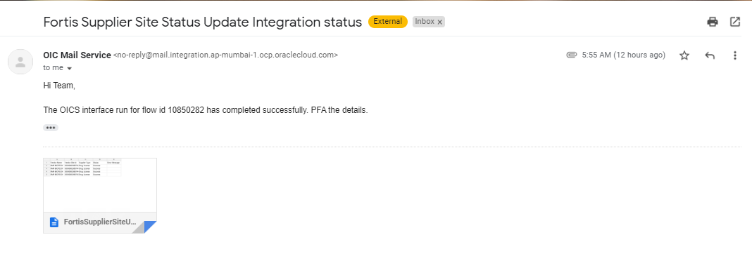

# Assumptions / Considerations

The Proposed Solution will have the following technical considerations.

In the future, if any product bug arises in functionality then this process needs to be revisited after the bug is fixed.

# Open and Closed Issues

## Open Issues

| ID | Issue | Resolution | Responsibility | Target Date | Impact Date |
| --- | --- | --- | --- | --- | --- |
|  |  |  |  |  |  |
|  |  |  |  |  |  |
|  |  |  |  |  |  |
|  |  |  |  |  |  |

## Closed Issues

| ID | Issue | Resolution | Responsibility | Target Date | Impact Date |
| --- | --- | --- | --- | --- | --- |
|  |  |  |  |  |  |
|  |  |  |  |  |  |
|  |  |  |  |  |  |
|  |  |  |  |  |  |